Burkina Faso

## Freedom House political status

The data set shows the Freedom House political scores and status of the country each year.

## # A tibble: 19 x 5  
## country iso3c date mean status   
## <chr> <chr> <dbl> <dbl> <chr>   
## 1 Burkina Faso BFA 1996 4.5 Partly Free  
## 2 Burkina Faso BFA 1998 4.5 Partly Free  
## 3 Burkina Faso BFA 2000 4 Partly Free  
## 4 Burkina Faso BFA 2002 4 Partly Free  
## 5 Burkina Faso BFA 2003 4 Partly Free  
## 6 Burkina Faso BFA 2004 4.5 Partly Free  
## 7 Burkina Faso BFA 2005 4 Partly Free  
## 8 Burkina Faso BFA 2006 4 Partly Free  
## 9 Burkina Faso BFA 2007 4 Partly Free  
## 10 Burkina Faso BFA 2008 4 Partly Free  
## 11 Burkina Faso BFA 2009 4 Partly Free  
## 12 Burkina Faso BFA 2010 4 Partly Free  
## 13 Burkina Faso BFA 2011 4 Partly Free  
## 14 Burkina Faso BFA 2012 4 Partly Free  
## 15 Burkina Faso BFA 2013 4 Partly Free  
## 16 Burkina Faso BFA 2014 4.5 Partly Free  
## 17 Burkina Faso BFA 2015 3.5 Partly Free  
## 18 Burkina Faso BFA 2016 3.5 Partly Free  
## 19 Burkina Faso BFA 2017 3.5 Partly Free

## Freedom House classification of political change

The data set shows the GDP growth and the ecomic growth classification of the country each year.

## # A tibble: 19 x 4  
## country iso3c date politicalChangeFH  
## <chr> <chr> <dbl> <chr>   
## 1 Burkina Faso BFA 1996 no change   
## 2 Burkina Faso BFA 1998 no change   
## 3 Burkina Faso BFA 2000 no change   
## 4 Burkina Faso BFA 2002 no change   
## 5 Burkina Faso BFA 2003 no change   
## 6 Burkina Faso BFA 2004 autocratization   
## 7 Burkina Faso BFA 2005 democratization   
## 8 Burkina Faso BFA 2006 no change   
## 9 Burkina Faso BFA 2007 no change   
## 10 Burkina Faso BFA 2008 no change   
## 11 Burkina Faso BFA 2009 no change   
## 12 Burkina Faso BFA 2010 no change   
## 13 Burkina Faso BFA 2011 no change   
## 14 Burkina Faso BFA 2012 no change   
## 15 Burkina Faso BFA 2013 no change   
## 16 Burkina Faso BFA 2014 autocratization   
## 17 Burkina Faso BFA 2015 democratization   
## 18 Burkina Faso BFA 2016 no change   
## 19 Burkina Faso BFA 2017 no change

## Freedom House score trend

The plot shows the Freedom House scores trend of the country.

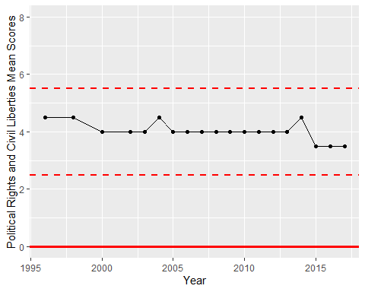

Freedom House Score Trend